The offered position is a role of high responsibility in providing *analytical reporting services to various financial, auditing and supply chain management departments* to End Client’s project name project. The position holds high significance in the project because *Business Intelligence reporting is critical to the company explicitly to determine if they are making profits or losing money. It helps the company understand their relationship between internal and external partners. Moreover, it helps the higher and lower tier management to study the current and historic trends to make sophisticated decisions for future*.

<Beneficiary Name> is primarily required to provide ***functional*** *and* ***technical*** *services to the departments associated with the project*.

* Functional Responsibilities
* Gather requirement and consolidate the outcomes.
* Analyze the architecture and list out the challenges and possibilities.
* Communicate and update the supervisors and higher tier management of other departments associated with the project about the progress and the timeline of the tasks.
* Interact and collect necessary information about their needs related to the project
* Technical Responsibilities
* Design and develop analytical and interactive reports for various financial and audit departments of <End Client>.
* Extract, Load and Transform data from different data source into target database systems.
* Implement data level and row level security in the applications.
* Execute the automation for technical procedures implemented in the system.
* Conduction high end testing and validation using canned and structured test cases before deploying the objects into production.
* Conduct administrative actions for deployment, migration, troubleshooting, access provisioning and system maintenance.

**PROJECT INFORMATION:**

***End Client Name: <End Client>***

As <End Client> is a multinational company and has its subsidiaries across the globe, it needs to systematic procedure to track its business and the navigation. Departments at <End Client> are relentlessly working in developing technologies in various streams and improving the network of their products that its consumers depend on. To track the financial progress, it needs a business intelligence process which can collect, consolidate and calculate their data and represent in intelligent and intuitive picture to help the departments analyze and make sophisticated decisions to help improve the business and raise their enterprise and economic standards.

<End Client> is *a leading power generation and supplying company with a successful reputation to provide electricity and other forms of energy from a wide spectrum of energy sources. They have transformed the whole energy industry with the digital power plant, gas turbines, high end sophisticated machinery and upgrade and service solutions along with their data-leveraging software*. <End Client> *has successfully redefined the power services more reliable, accessible, sustainable and affordable*.

[insert weblink end client information found from (date webpage viewed)]

**Brief narrative about the <project name>project**:

The Software Developer position involves important and critical decision making and must be understood in its context.  The software being developed and enhanced is a critical software to the <End Client>.

**About the [Methodology/Technology]:**

The key agenda of the project is to collect raw data from diverse sources, then transform the data into information, and turn the information into intelligence by using business intelligent tools and applications as per the requirement. FDW has a data warehouse which accumulates data from 5 different ERPs by integrating with their respective Enterprise Business Suite’s database tier. FDW also fetches data from 4 different SAPs and integrates the data into the ERP data where ever required. FDW contains multi-year data stored in multi-granular format but represents data by following only relational database management techniques.

Data is loaded using Oracle Data Integrator (ODI 11g) which is integrated with the source ERP database systems and SAP source systems, through scheduled load plans for all the 5 ERPs. Data is scheduled to be loaded once every day unless ad-hoc request are made by the management. During Month-end and Quarter-end, these loads run 28 times each day for approximately 12 days.This data is aggregated and formulated to be compatible with OBIEE terminology to be used in the front-end user interactive reports. As these reports needs to be intuitive, the backend data is granulated separately as per departmental specifications and guidelines to ensure higher management can gain valuable information and utilize these reports for making appropriate business decisions.

**Project Details:**

The <End Client> <Project Name> *project provides analytical and intuitive reporting services to various financial and audit departments in <End Client> and its subsidiaries across the world*.

* *To deliver these services, FDW uses the following applications,*
* *Oracle Business Intelligence Enterprise Edition 11g (OBIEE 11G)*
* *Oracle Data Integrator (ODI 11G)*
* *Oracle Exadata machine integrated with Oracle 11g Database*
* *Red hat SELinux*
* *Oracle Data Relationship Manager (DRM)*
* *Oracle Enterprise Manager – Performance Management System*
* *As of now, more than 2000 inter/ intra business users utilize FDW applications directly for a wide range of services.*
* *FDW supports and provides services to different business departments in <End Client> and its accruals like Digital Energy, Power Generation Services, Distributed Power, Nuclear Energy, Water and Process technology, Renewable Energy, Alstom and Grid Energy Services, Air Quality Control system, and other power generation and distribution departments.*
* *These departments rely on FDW for calculating and analyzing financial KPIs in form of*
* *Revenue*
* *Expenses*
* *Profits*
* *Loss*
* *Capital*
* *Cashflow*
* *Income Statements*
* *Data is extracted, modulated, aggregated and transformed into complicated analytical views to describe business intelligent reports pertaining information regarding Transaction Registers, Income Statements, Trial Balances, Inter/ Intra company and trading partner relationships, Cash Flow Statement, Balance Sheets, Profit and Loss statements, Stock holder’s equity, risk assessment reports, Sales Account Reports, Uniform Organization Structure reports.*
* *Users can run these reports and export in excel, PDF, CSV and power point format for conducting extensive analysis.*

**Below are the steps to accomplish this Project requirement.**

**Requirement Analysis –**

Project/ Task is envisioned, and user expectations are analyzed as per priorities. Possibilities and challenges are streamlined, and proper design is planned after business user’s and developer’s agreement and approvals. Team must perform proper assessment of the data sources and analyze the compatibility with the applications that they use for the project. Compare the requirement with previously achieved targets and reminiscent timeline is decided. Gathered requirement is documented in the tickets and service requests and estimated time of completion with sufficient buffer period is declared in the planning tools. <Beneficiary Name> is crucial in the following stage and performs the core decisive actions in this stage.

**Data Extraction and Processing –**

Data is identified, and the source system is defined in the Oracle Data Integration tool (ODI 11g), which follows the methodology of Extract- Load- Transform and is loaded into the target data warehouse. Current source systems for FDW are 5 different ERP and 4 Different SAP systems. Metadata Hierarchical structures are loaded using Data Relationship Manager (DRM). Balances and income statement is collected from Hyperion Financial Management (HFM).

* Extraction: Using topology manager in ODI, Source systems and source files are integrated with the data fetching packages. These packages are designed with data processing interfaces, knowledge modules and procedures. Raw data is extracted from the source and loaded into the staging tables which are predefined while developing these interfaces.
* Loading – Making use of RKM (reverse-engineering knowledge modules) and LKM (loading knowledge modules) in the interfaces and the packages, metadata is integrated from the source to the staging and target area based on the design and compatibility. These actions are performed based on the configuration of topology and data model structure through the logical schema defined in the objects. Data alteration like insert or update is conducted during this stage.
* Transform – This is the most important stage in data processing because this is where raw data is transformed into compatible and logical data. Making use of relational database management techniques and other knowledge modules like IKM (Integration Knowledge Modules), CKM (Check knowledge modules) and SKM (Service Knowledge modules), data is aggregated and defined logically to be used for reporting. Data alteration can also be conducted in this stage using DML (Data Modification Logic) techniques.

<Beneficiary Name> has extensive expertise in the above discussed concepts and methodologies and thus performs the actions and delivers the content for further development.

**Reporting Foundation-**

After the data is loaded into the target tables, this data needs further transformation and needs to be joined with multiple tables from different journals to be compatible with the reporting guidelines. Using Oracle Business Intelligence Repository, metadata from data warehouse is fetched and is allocated in the development layers. In the repository these tables are joined internally with each other based on the reporting criteria and are saved as subject areas that can be used for developing reports to display data in intelligent and intuitive format.

<Beneficiary Name> has extensive knowledge and is an expert in modulating and transforming data using the repository.

**Reporting –**

Once the reporting foundation is laid out, the repository is deployed into the presentation server of the OBIEE application using enterprise manager.

Reports are developed in the presentation analysis portal where subject areas from the repository are used to get the entities and extract valuable information from the defined sections. These reports are developed in various formats supporting tabular, pivot, reports with drill-down features, graphs, charts, Pie-charts, geo metric format, tile representation, Trellis, Gauge, Column selectors, etc.

<Beneficiary Name>, utilizes his skills and expertise to creatively design various formats of analytical views for the data pertaining for finance, accounting and other hierarchical modules containing information supporting General Ledger, Account Payables, Account Receivables, Sales, Revenue, Transactions, Expenses, Assets, liabilities, Region, Company, Trading Partners, profit centers, cost centers, cashflow statements, income statements, and other hierarchical reports.

**Testing and Validation –**

Logical and technical test cases are designed to validate the designed reports have a robust analytical system. Reports are subjected to complicated test cases against both dummy and practical data. After the initial testing phase is complete, the reports are deployed in UAT (user accepted test) environment where it is tested against real-time data.

<Beneficiary Name>, designs and formulates all the test cases and validate the reports and then demonstrate them to the users for further validation.

**Demonstration-**

Reports are demonstrated to the superiors and other front-end business users. Reports needs to be explained in business terminology. Beneficial justification needs to be proved in these conferences to make sure they pass the user approval for production deployment. Business users needs to be trained to use these reports and should take down comments and feedbacks for any kind of enhancements and corrections.

**Deployment-**

After validation, reports and other catalog objects needs to be subjected to performance tuning test and then are prepared for production deployment. Production environment is shut down and is not available for usage during deployment. After the deployment, reports are tested again, and final confirmation is sent to all the departments associated with the new reports and dashboards. All the migration and deployment operations are conducted on Unix machines where each application is installed and controlled.

**Architecture diagram for current Project**

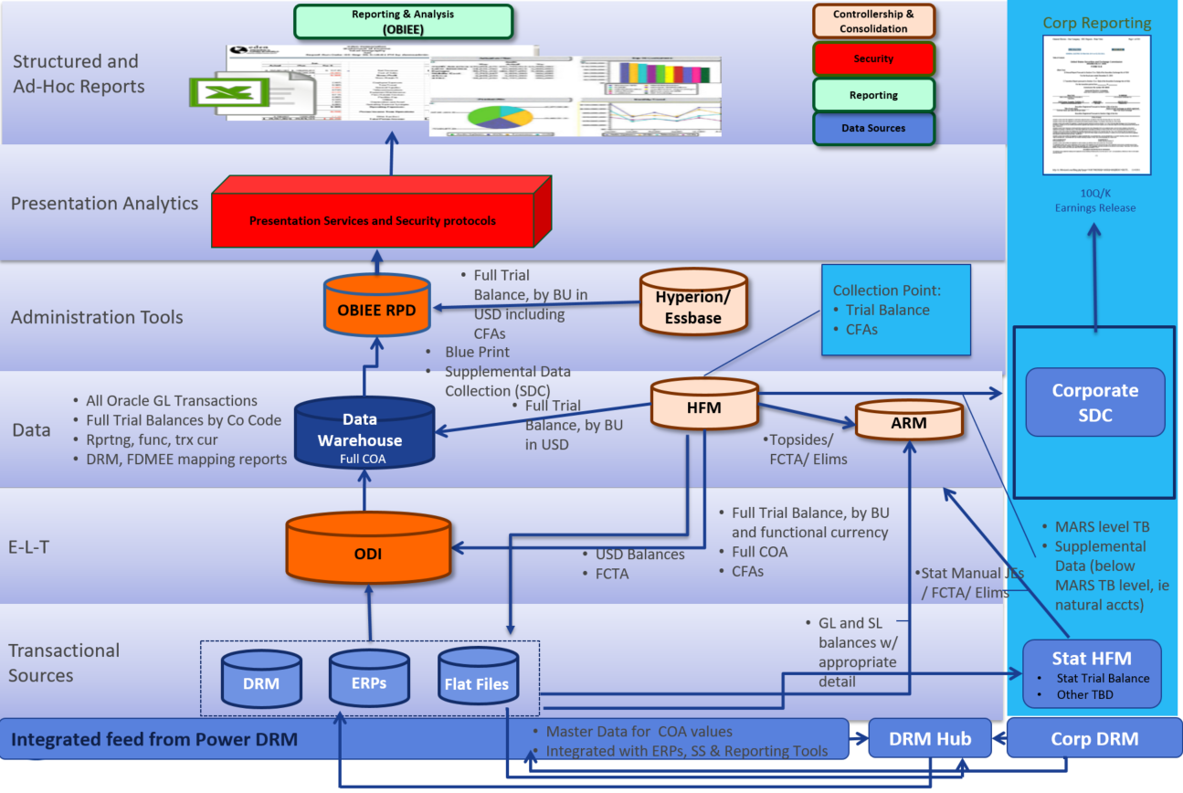

*OBIEE: Oracle Business Intelligence Enterprise Edition*

*ODI: Oracle Data Integrator*

*ERP: Enterprise Resource Planning systems*

*HFM: Hyperion Financial Management*

*DRM: Data Relationship Manager*

*RPD: Repository*

*E-L-T: Extract – Load- Transform*

***Beneficiary’s Day to Day work:***

***Requirement gathering:***

* *Whenever there is a new requirement, users reach out to the FDW Team through ticketing systems, ALM (Application Life-Cycle Management), Service-Now, and GE internal Community central case logging system.*
* *<Beneficiary Name> begins the assessment program for the request and study the requirement documentation provided by the business user or department and conducts requirement analysis meetings with the business users to review the specifications.*
* *The expectations are envisioned, and outcomes are laid out while keeping the challenges in the loop. Possible workarounds are suggested for impossible and unrealistic expectations. Once the requirement is gathered, the collected information is discussed with the offshore team and each task is divided among the team based on the skillset and availability.*
* *High level design for extraction, loading and transformation is prepared to identify the source systems that contain the required data modules.*
* *Source and target dependencies are listed out to make sure that implementing the new task will not hinder any performance or impact any of the existing design.*
* *A Proof of Concept (POC) is designed and is demonstrated to the project manager and project owner along with the business users to depict the overall functionality to take any suggestions for modifications or enhancements before initiating the design and development process.*

***Design:***

* *Come up with a detail design document for achieving the target within the expected time line. This plan includes the Extract-Load-Transform process flow layout giving the idea about the source and target database and data warehouse systems.*
* *Design document should give a gist about the objects involved in the data processing packages, data load timings, triggers, agents, dependencies, scripts and procedures.*
* *Design document should briefly describe how the target tables/ Meta-data will be relationally mapped or joined in the OBIEE Repository, what key columns will be used for joins and what would be used for aggregations.*
* *A sample diagram from star schema and snowflake schema should be added to the diagram depicting all the possible tables joined together defining the dimensional and factual relationship.*
* *Document should also mention about the security layout and implementation criteria for each object.*
* *Sample report snapshots or layouts should be added in the documents and should be verified by the user to ensure we are providing the reports as they envisioned.*

***Development:***

* *Configure source systems in logical and physical architecture under topology manager in Oracle Data Integrator.*
* *Create Data store models in the designer manager and enable all the meta-data entities for all the data stores.*
* *Create procedures and interfaces based on the logical design planned to extract, load and transform data into staging and target tables based on the design plan.*
* *Implement knowledge modules in each interface based on the functional methodology required for the package.*
* *To enable execution of the package, create a partial generated code known as scenario and consolidate all the scenarios in load plans and independent execution plans.*
* *Use the target data stores and establish the link in the OBIEE Repository to aggregate and conjugate the data into subject areas which can be used for reporting.*
* *Align and construct star schema and snow flake schema in the physical and logical layer of the repository using the meta-data structures.*
* *Categorize the data models as per enterprise standards and arrange them under subject areas that can be used for reporting.*
* *Using the presentation services, design and develop analytical reports by adding data entities from the subject areas created in the repository.*
* *Create the reports using various views available in the OBIEE application like tabular views, pivot, reports with drill-down features, graphs, charts, Pie-charts, geo metric format, tile representation, Trellis, Gauge, Column selectors, etc.*
* *Utilize concepts from managerial accounting, Procurements, Sales analytics, Cost Accounting, Auditing, etc., to build financial reporting through OBIEE application.*
* *Create shell scripts for fetching data from file data sources and automate these scripts using   
  CRON jobs (Linux utility used to schedule or automate command or scripts on the server).*
* *Implement row level and data level security to the table structures in repository and application level security to the catalog objects in the presentation services (Reporting portal).*
* *Create OBIEE agents for scheduling and automating the reports to run and deliver the reports in excel format to the users emails directly.*

***Testing Phase:***

* *Create practical test cases for subjecting the reports to pass and prove the validity for approvals. Communicate and coordinate with business users and other functional users to utilize the test cases for validation.*
* *Involve source technical teams to provide data in the quality analysis environment to implement the test cases.*
* *Collect feedback from the users and work on any corrections or enhancements and re-deploy for SIT and UAT.*
* *Document the performance metrics and conduct behavior analysis on the report objects and catalog objects to ensure smooth transition and execution in production.*

***Production Deployment:***

* *Coordinate with the technical and business teams for production deployment.*
* *Business and functional users are communicated through emails about the outage window when production environment will not be available due to deployment activities.*
* *ODI and OBIEE objects are archived and migrated to the production environment using WinSCP tool to transfer objects from lower tier environments to production environment.*
* *Once the catalog objects are moved, then the OBIEE repository is deployed into the presentation analytics using enterprise manager portal and all the BI services need to be rebooted after the deployment.*
* *Functional and Business users are communicated about the completion of the deployment and outage.*
* *A fail-over plan is prepared and kept ready for any unsuccessful migration.*
* *Need to request for approval from senior management for Release Management Change Control Process.*

***Production Support:***

* *Users communicate to FDW team using the ticketing systems like ALM (Application Lifecycle Management), GE Support Central, IDM (Identity Management Manager) and Service now.*
* *For any issues reported, action needs to be taken immediately depending upon the severity level.*
* *Issues are reproduced by using the examples provided by the users and then the source of the issue is investigated.*
* *Data transformation logic and data modulation logic is subjected to test by applying the fault data examples while the flex-field points are validated at every point of data flow.*
* *Data processing procedures are executed in debug mode to verify the issue and transformation logic in the E-L-T job or the Reporting procedures.*
* *Once the issue is identified, corrective measures are taken in lower tier environment and are subjected to user acceptance test.*
* *After necessary approvals, the corrected code and modified reports are deployed in production.*

***Administration:***

* *Execute the deployment process through archiving and migrating catalog and ODI objects from lower tier environment (Development and QA) to production environment.*
* *Setup active directory access security in the application and maintain and monitor security system in WebLogic server and BI Server. Provision access to business users to the reporting environment using LDAP (light-weight Directory Access Protocol) and Web SSO groups in Distribution lists*
* *Assist the Unix team for patching activities on the server and the applications.*
* *Troubleshoot for any system failure over Unix machines by using Linux utility tools like Putty, Super Putty and WinSCP.*
* *Monitor the data loads using BIACM and ODI Console and troubleshoot for any issues if occurred.*
* *Maintain system and application reliability by constantly monitoring the performance stats and usability spikes in Oracle Enterprise Manager and Oracle Business Intelligence Console.*

***Other Functional Responsibilities***

* *Review reporting requirements with stakeholders, identify source systems of the requirement and list out the possible outcomes and challenges.*
* *Coordinate and translate technical issues and limitations to the business users and the team members.*
* *Carry functional responsibilities by communicating with offshore team members and business users and streamline the requests on a systematic platform*
* *Track and streamline defects and cases logged by the business users raised through ticketing systems like ALM (Application Lifecycle Management), GE Support Central, IDM (Identity Management Manager) and Service-now*
* *Coordinate and train business users and help them run and understand the interactive pivot views for their respective department.*
* *Project is associated with different teams with diverse work cultures, <Beneficiary Name> needs to coordinate with all* these teams to ensure smooth working of all applications involved in the project.

**Please also see Beneficiary’s work samples below**

**Oracle Data Integrator**

**Connection Setup:**

Snapshot below is from the ODI Client, to show where different sources discussed above are defined.

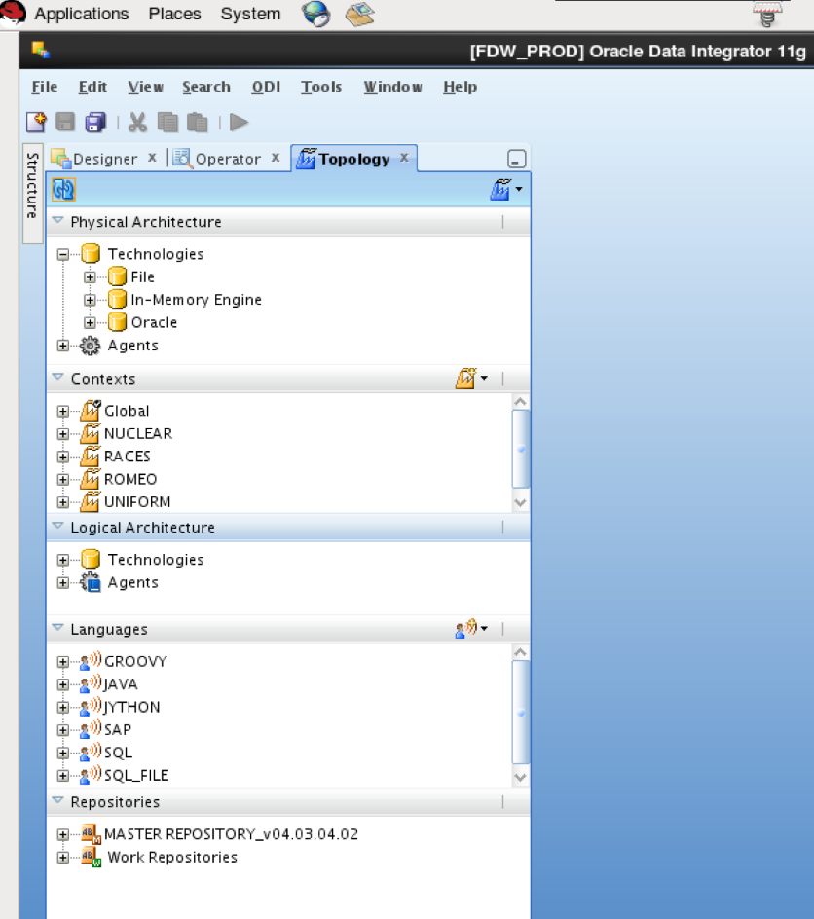

**Data store and mapping creations:**

Snapshot below is from the designer module, where data stores are defined and packages with mapping and formulated objects are designed

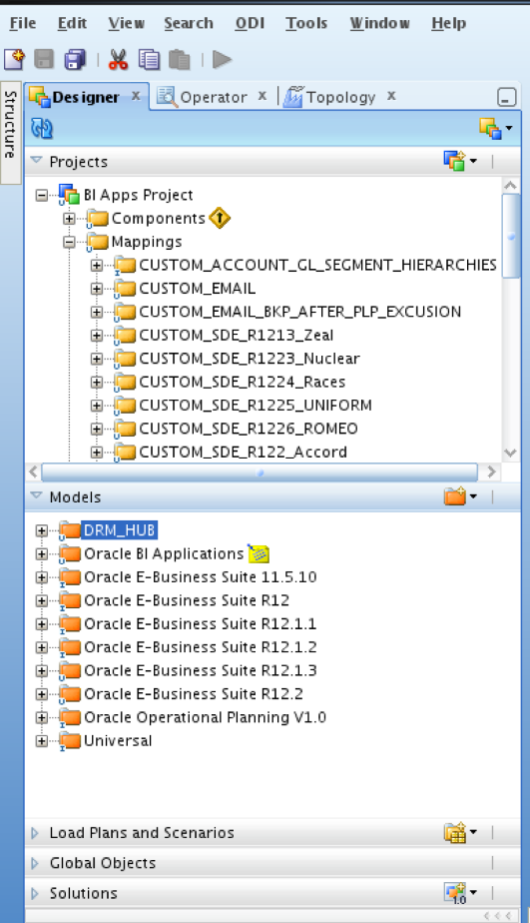

Examples of Packages and interfaces for developing the Extract loading and transforming data

Snapshot below, is to show where we use the meta-data from the data sources

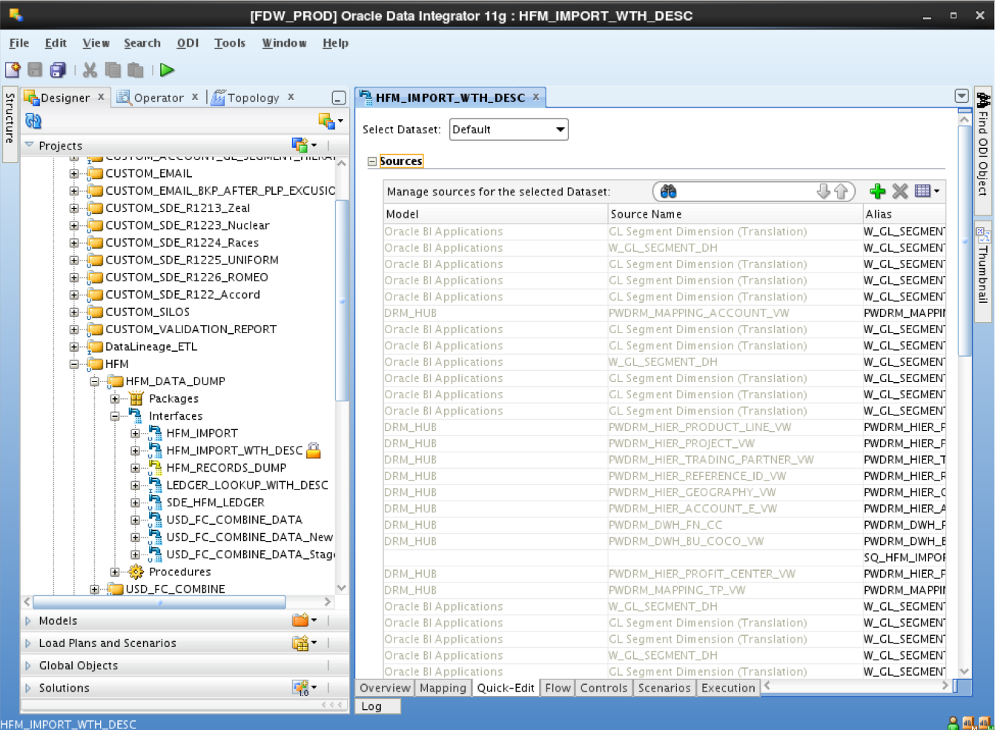

Snapshot below is to show how we establish relationship between different data stores

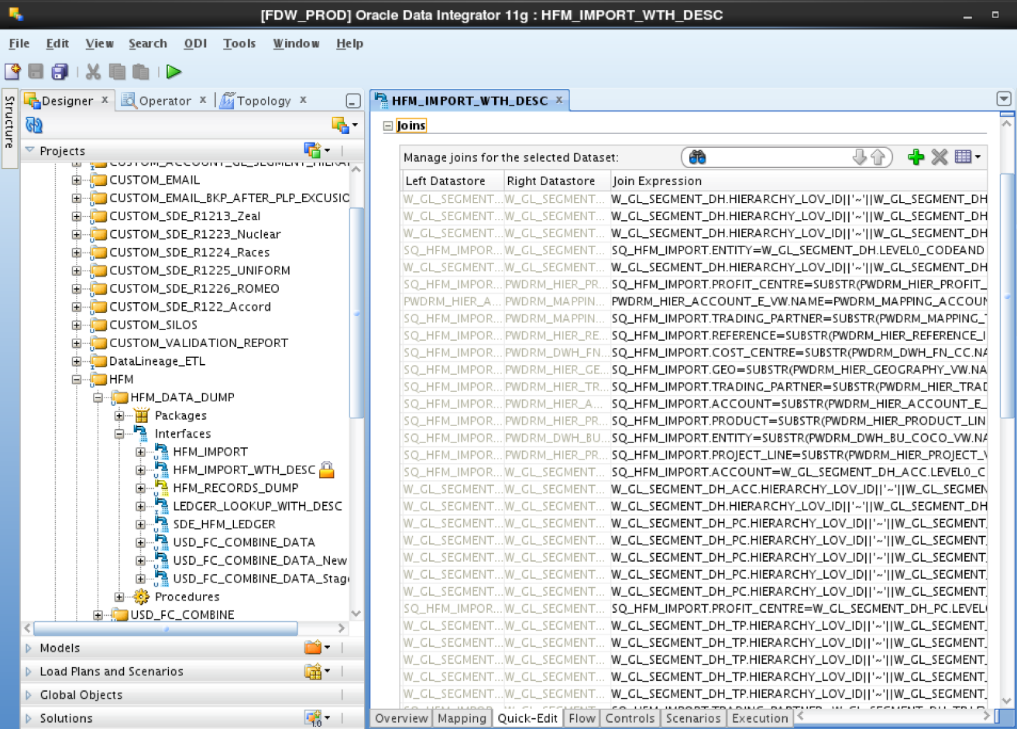

The snapshot below is to show how we define each column for the target tables

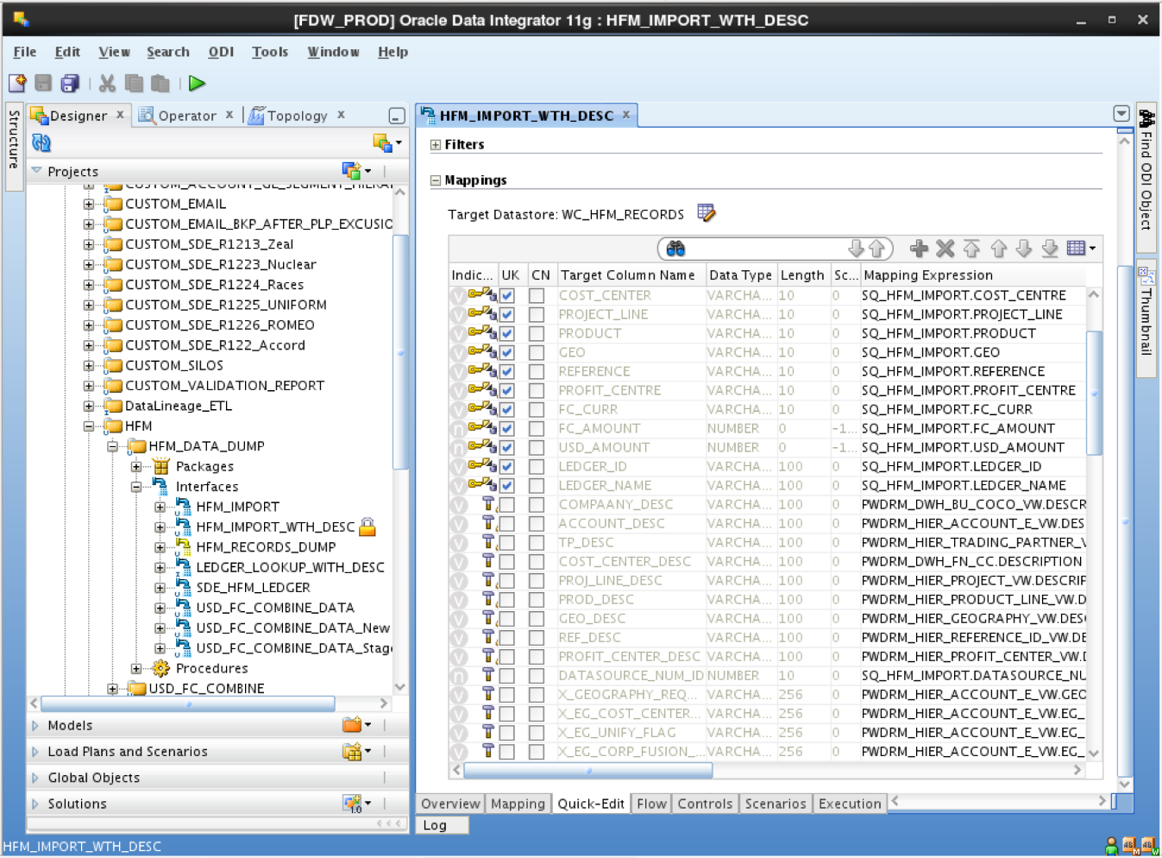

Snapshot below is to show how we schedule load plans and assign the designed packages and scenarios to it.

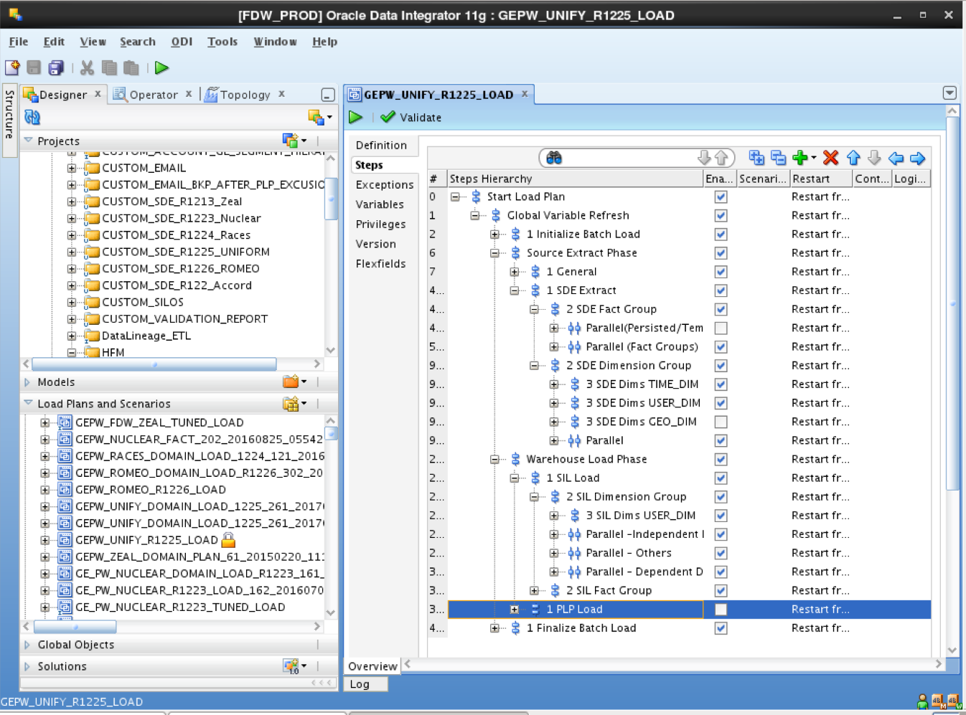

Snapshot below is an Example of back end codes that we use to design the loading procedures.

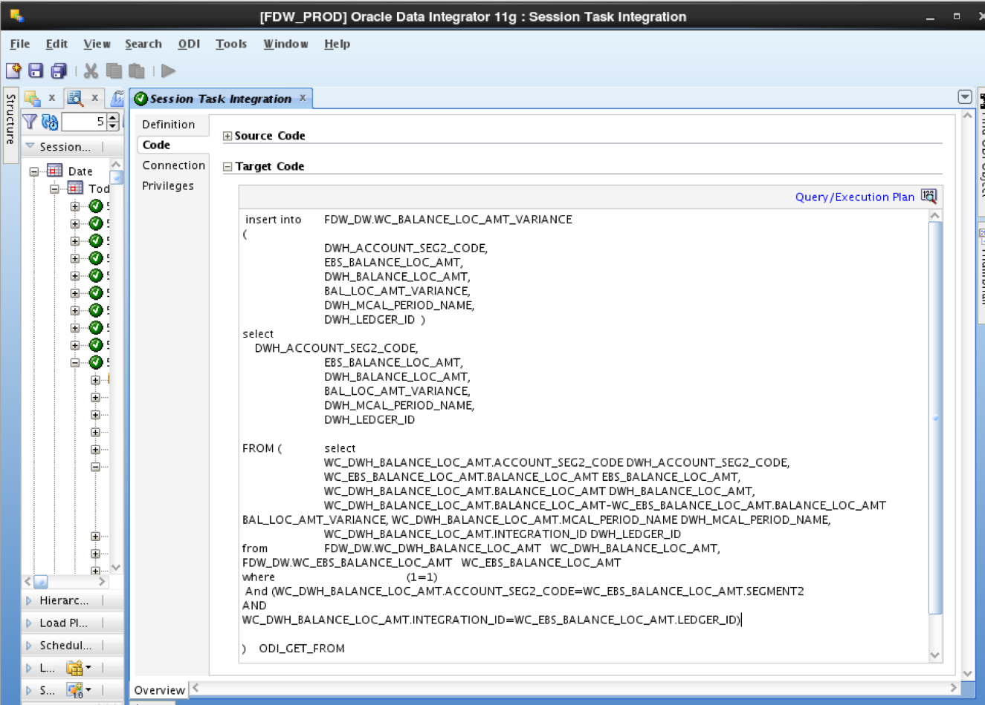

Some more examples to show the data flow

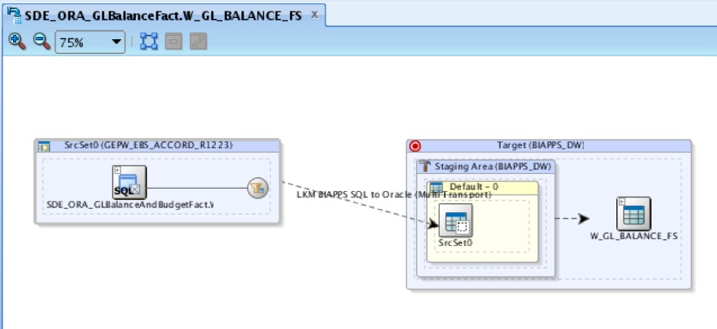

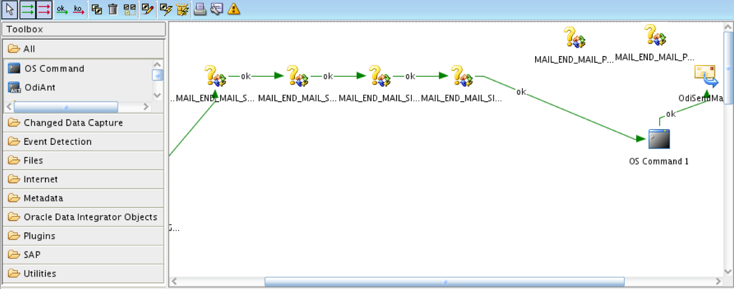

Developing robust data loading procedures and load plans with great performance timing using ODI requires thorough understanding and expertise on various database transformations and application components. Data Warehouses are built on Oracle servers integrated with Unix machines. Working in this environment requires exceptional SQL scripting skills and Linux background. Proficiency in Data Manipulation Language (Insert/ Update/ Delete scripts) and Data Definition Languages (Create/ Alter / Drop scripts) is needed to communicate with databases.

**OBIEE (Oracle Business Intelligence Enterprise Edition)**

Snapshot below is to show how we utilize the FDW tables in the repository to define logical relationship between the metadata and transform the data into information.

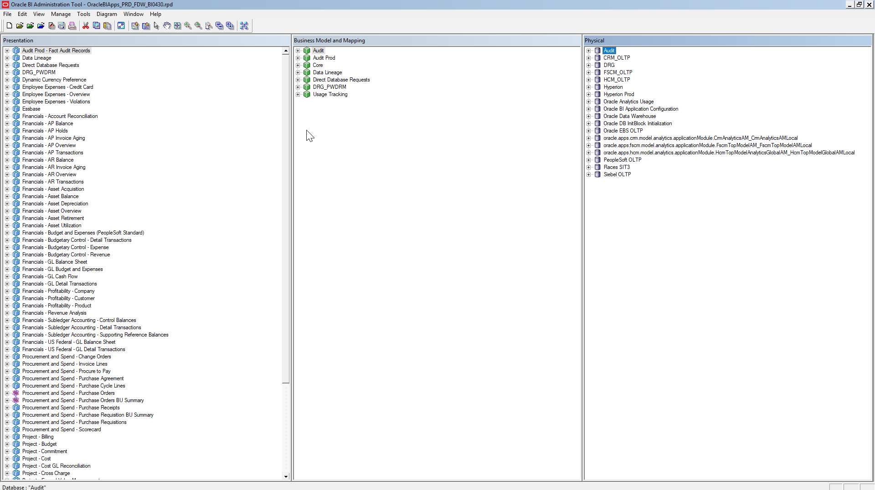

Snapshot below is an example of Star Schema for Data Modulation

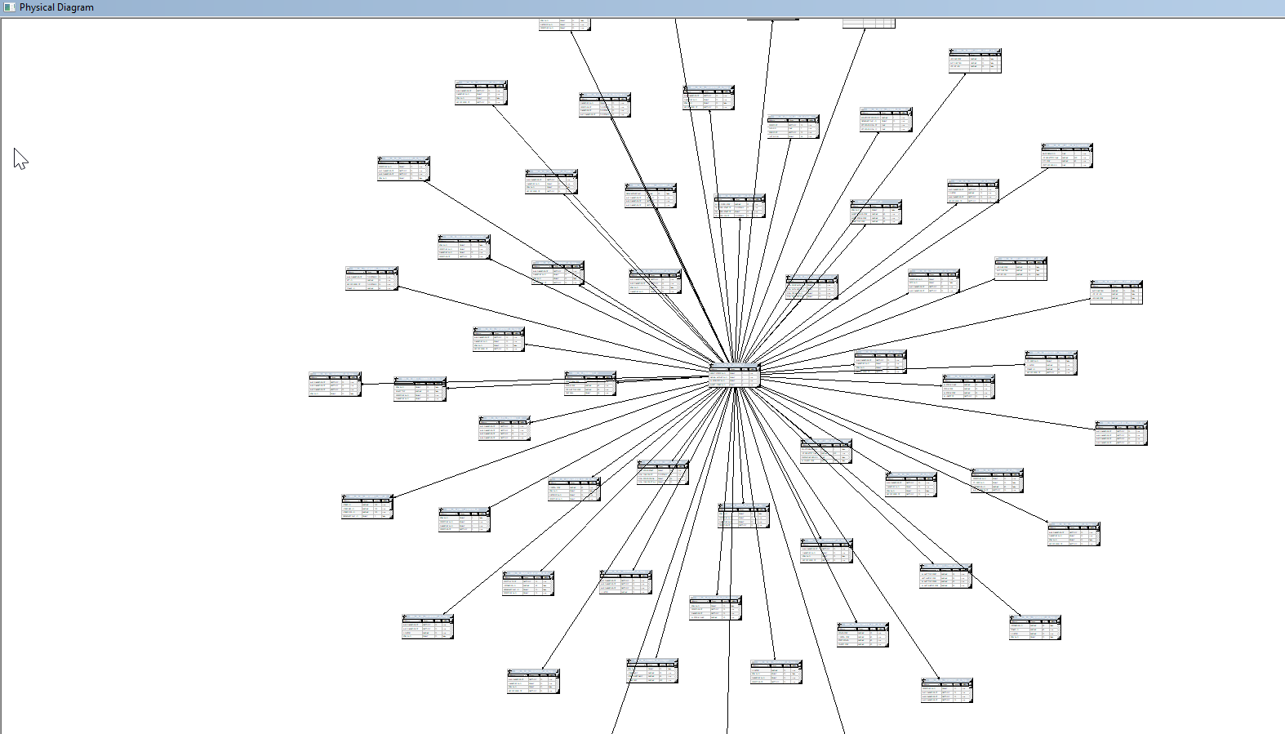

Snapshot below is to show how two tables are joined

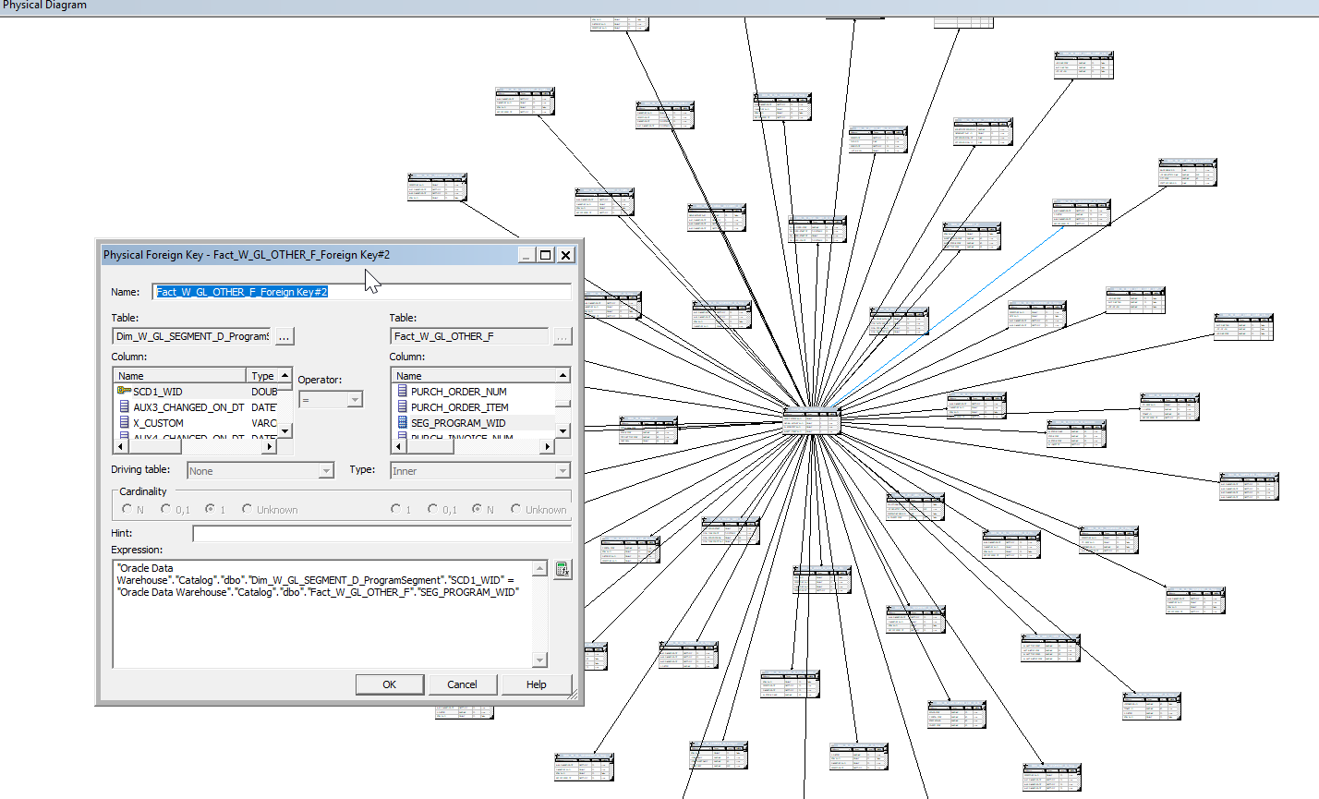

Snapshot below is to show how hierarchies are defined

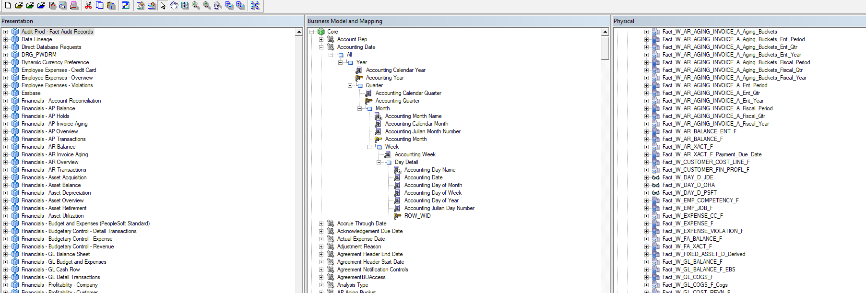

**Dashboards and Reports**

OBIEE Home Page

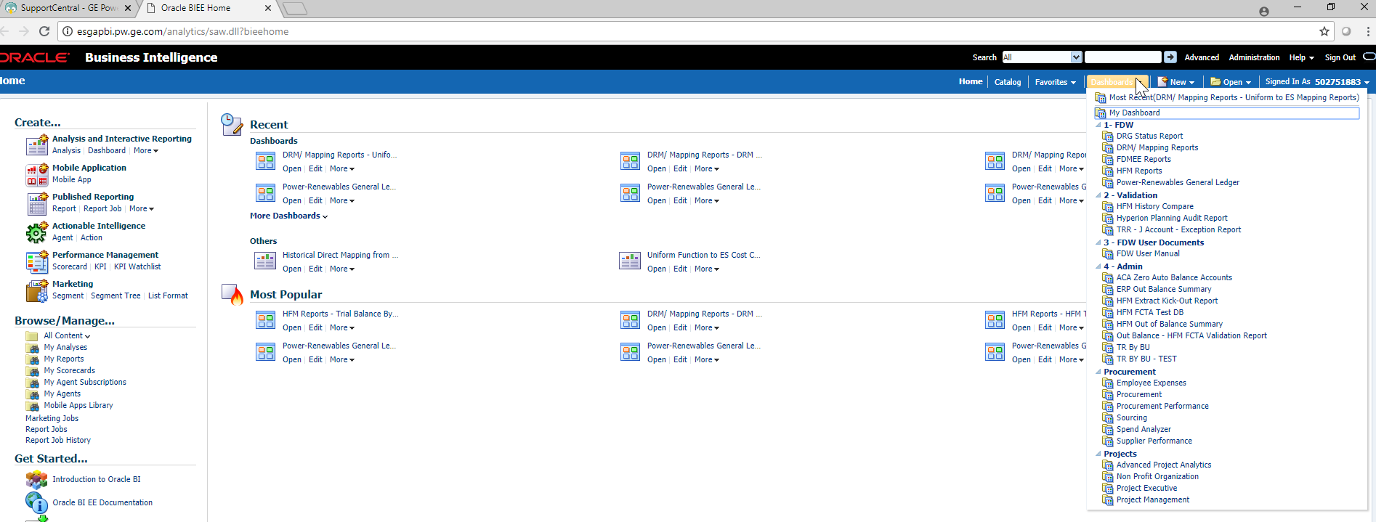

Snapshot below is for a Sample dashboard

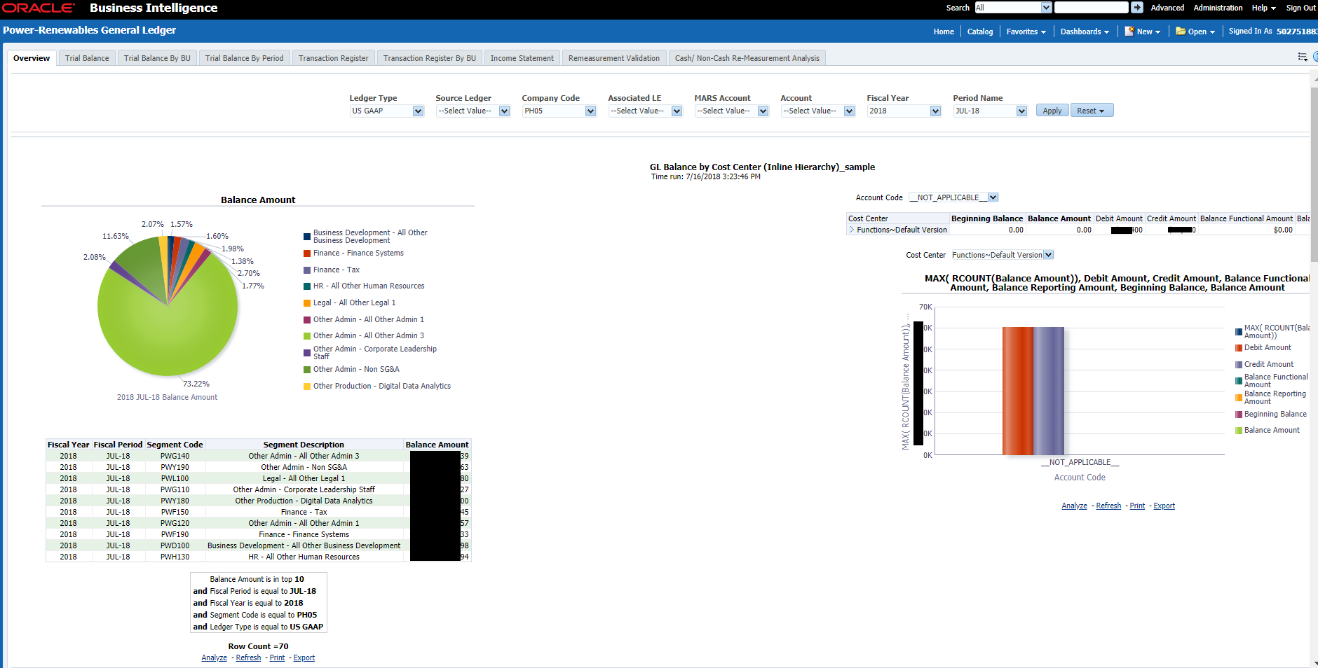

Amounts and factual data is blacked out for confidentiality reasons.

Snapshot below is an example to show how the reports are built in the backend. Metadata is pulled from the subject areas and are aligned based on the relationship and appropriate formulae and aggregation is defined in each module of the column. Filters are defined in the last section to enable the interactive feature in the reports.

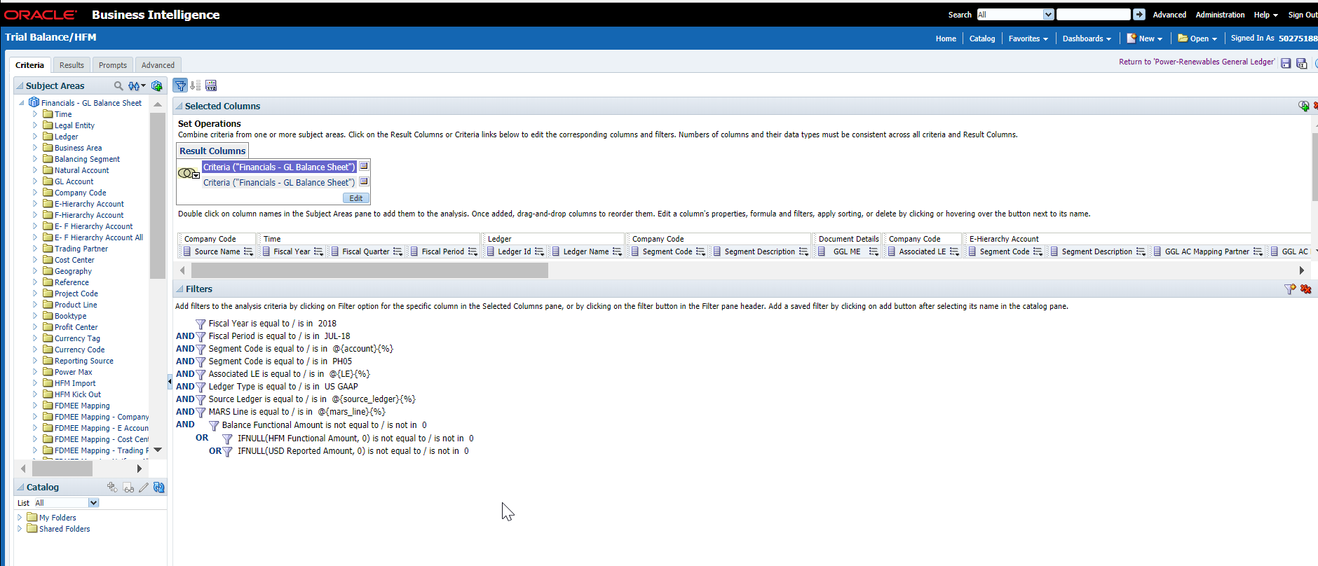

Snapshot below is to show how the aggregations are defined in the column

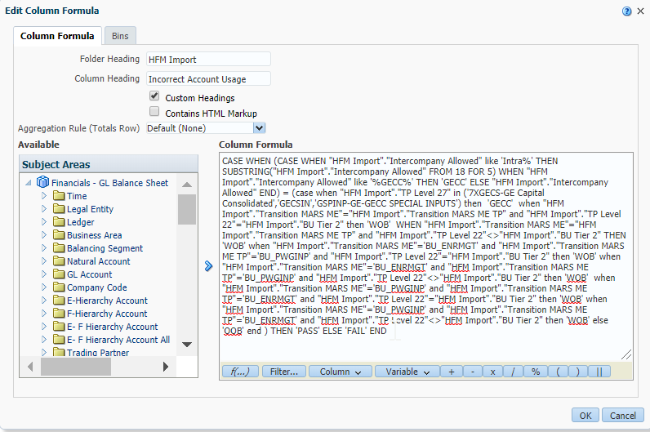

Reports are dynamic which depicts both real-time and historic data. Reports also respond to the frequent currency fluctuations and display the values dynamically so that users can consolidate and audit their data accurately.

Below are the snapshots to show how the system reliability is managed and monitored.

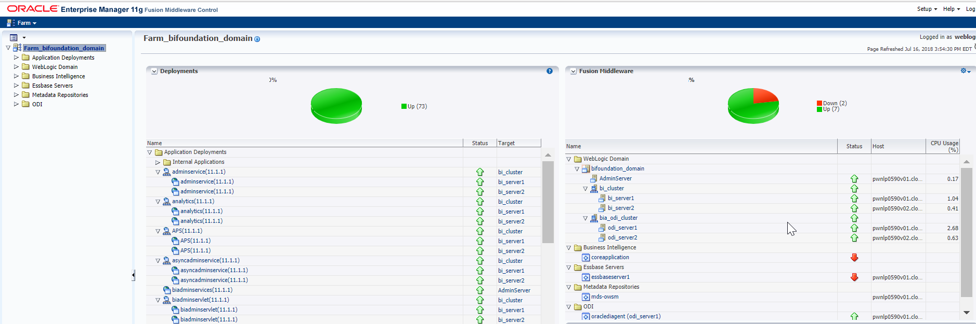

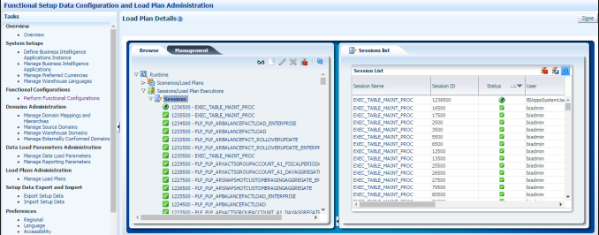

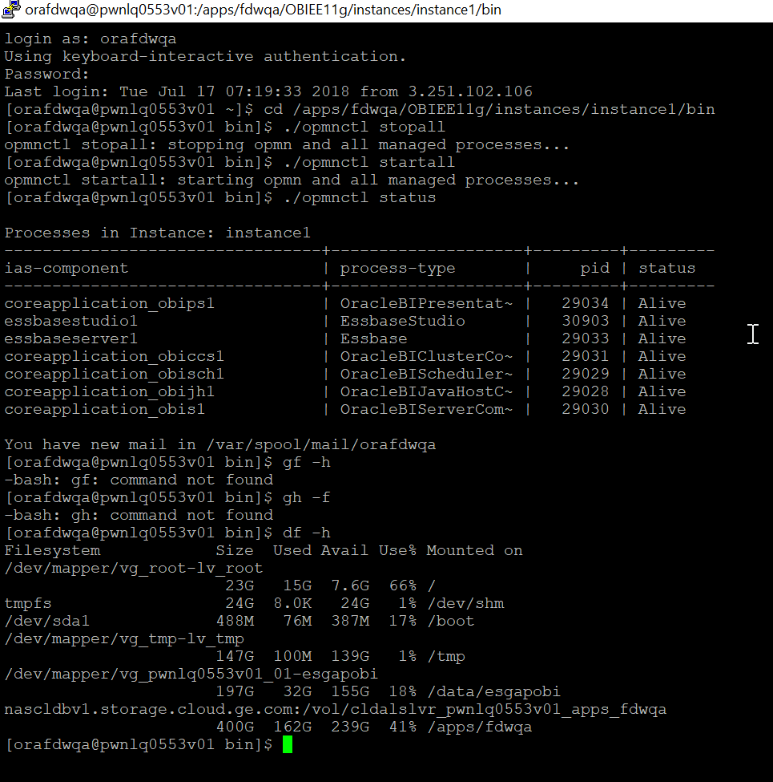

Below is the snapshot for the shell script

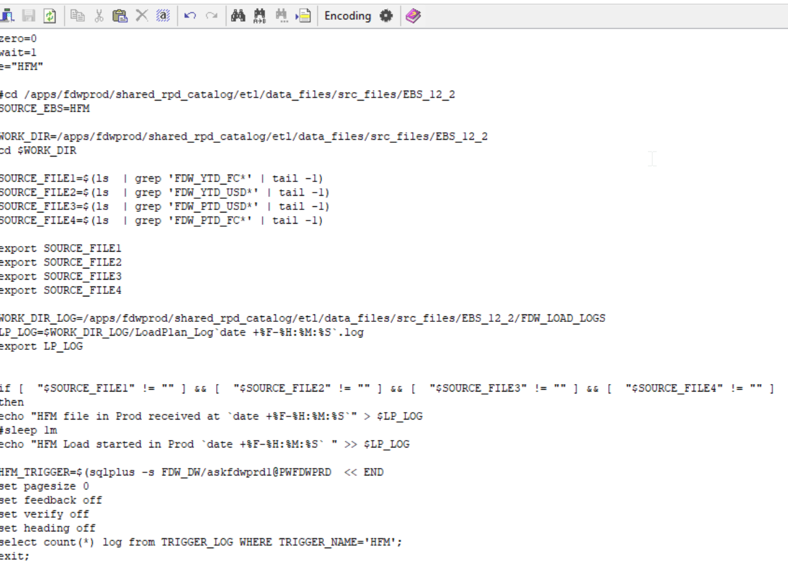

Below is the snapshot for the ODI Load plan executions during month-end book close. FDW has 6 different load plans scheduled periodically. Usually FDW runs these loads once for each source but during month end close FDW receives 28 loads in one day and this process runs for 10 to 11 days every month. <Beneficiary Name> must constantly monitor the load plans during Eastern Time Zone (EST).

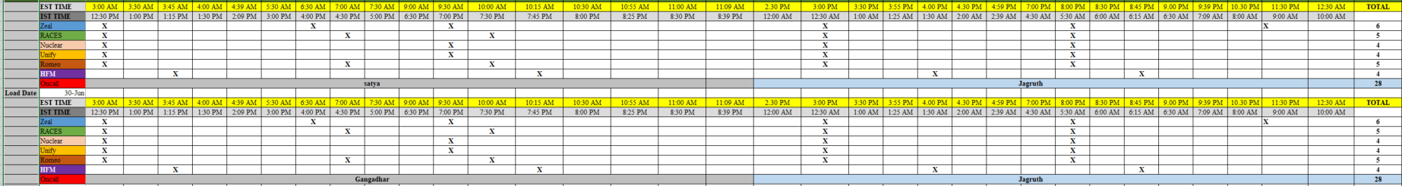

Snapshot below is to show how we track our tickets and progress

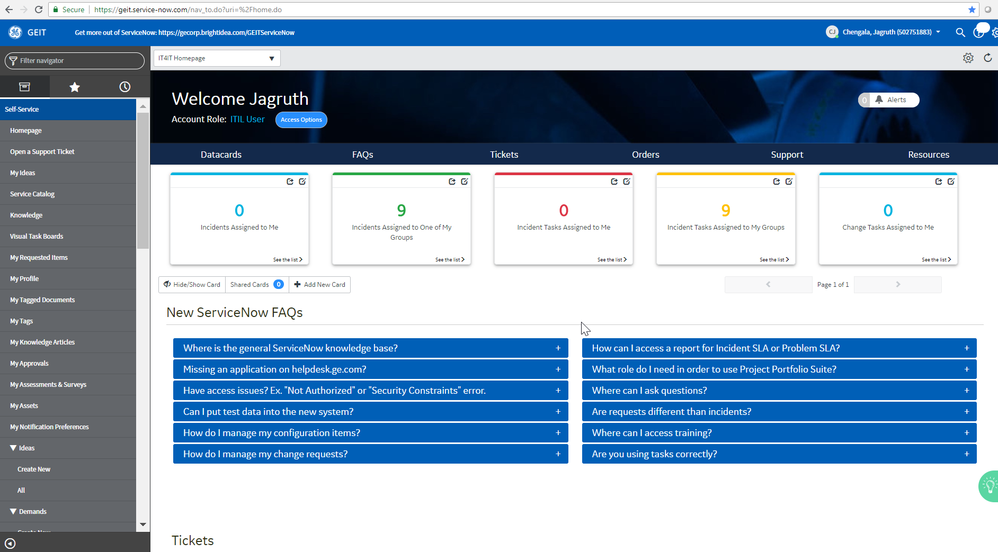

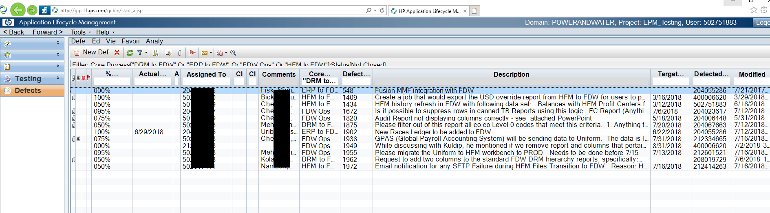

Some of the information is blacked out for confidentiality reasons

More specifically, the <Job Role> is involved in the development and maintenance of the project to deliver high-end analytical reports with complicated aggregations to provide intelligent information to the departments associated with the project in order to help them make sophisticated decision to improve the business.

It is clear from the provided position description that the position of <Job Role> is a professional-level position that requires such specialty knowledge and skills. As discussed above, the <Job Role>'s work is focused on the full-cycle development of E-L-T and Reporting systems. Because E-L-T systems must integrate with multiple source systems to obtain data, and to deliver this data as valuable information, their development necessarily requires the work with a variety of tools and technologies. This includes working with specialized data processing tools to obtain ERP, Non-ERP and SAP data, writing SQL database queries to modulate the data as per reporting standards, writing file parsers and scripts to obtain data from flat files, and automating the file extracting and loading procedures by using ODI load plans and Cron Jobs. Working with this variety of source data systems requires specialized knowledge and skill of programming and software development, Architecture Analysis, Requirement Engineering, Testing and Validation, Information Security Systems, object-oriented programming, web protocols and technologies, comparative studies of technical languages, databases, systems programming, automation, and related areas. These types of specialized knowledge are associated with a bachelor's-level degree and are indicative of a professional-level position.

It is also notable that while the <Job Role>’s work is focused on Business Intelligence systems, the position also requires particularly specialized work with data design and relational database systems. <Job Role> must be able to understand and envision the final picture of the output and be able to architect and design the navigation from source system to front end graphical report design. Furthermore, <Job Role> must apply in-depth knowledge of Repository structure and data processing concepts to optimize the performance of the reporting and data loading systems. This requires specialized knowledge of relational database systems, requirement engineering, data structures, object-oriented programming and execution and optimization techniques.

Together with the array of technologies associated with the <Job Role>'s work designing Business intelligence systems, it is clear that the position of <Job Role> is a professional position.

***A Detailed breakdown of job duties table into tasks and subtasks at the micro-level***

|  |  |
| --- | --- |
| **Detailed Description of Each Duty and Responsibility** | **Percentage of Time Allocated on Each Duty** |
| **Design, develop and modify ETL packages (data transition procedures), SQL Procedures, Knowledge Modules and scenarios on Oracle Data Integrator 11g.** | **20% of the work time** |
| * Identify the source systems and data processing logic for each requirement. | 2% |
| * Configure the source datastores and develop the ETL packages with Interfaces, knowledge Modules, SQL Procedures and scenarios. | 12% |
| * Link each scenario based on the Sequential/ Parallel processing logic and activate the automation load plan for aggregating and loading the data. | 3% |
| * Create and execute Shell scripts to fetch flat files and also for activating triggers to initiate and manage ODI loads and send notifications. | 3% |
| **Design and develop complex SQL based queries and packages using RDBMS guidelines using Oracle SQL developer and implement them through ODI and BI Analytics.** | **20% of the work time** |
|
| * Write PLSQL queries for modulating and processing data from Non-ERP and Non-Relational data sources. | 5% |
| * Create complex SQL packages and schedule them using Oracle Scheduler and agents through ODI | 7% |
| * Create structured and materialized views in the repository to build opaque analytics for complicated dimensions and fact tables. | 8% |
| **Setup active directory access security in the application and maintain and monitor security system in WebLogic server and BI Server. Provision access to business users to the reporting environment using LDAP (light-weight Directory Access Protocol) and Web SSO groups in Distribution lists.** | **10% of the work time** |
| * Configure and maintain the LDAP in WebLogic console and assign the users from Active directory, proper access to run and view the reports. | 5% |
| * Configure and monitor report executions based on the security access provisioned to the functional department. | 3% |
| * Monitor user traffic and user activity and log usage tracking statistics in the system | 2% |
| **Monitor data loads using BIACM and ODI Console and troubleshoot if required. Create and execute Unix/ Shell scripts for activating triggers to initiate and manage ODI loads and send notifications.** | **10% of the work time** |
| * Monitor the data loads using BIACM and analyze the performance variation while troubleshooting with severity level 1 to ensure smooth transition of data. | 7% |
| * Create Shell scripts to automate a trigger process to enable the ODI Loads based on the ERP and other source systems. | 3% |
| **Handle administrative activities which includes planning and execution of migration and deployment for scheduled and ad-hoc requests. Assist with patching activities and troubleshoot for any issues on WebLogic server, BI Server and OPMN services.** | **10% of the work time** |
| * Prepare the environment for Migration by streamlining the repository and deploying it in enterprise manager | 2% |
| * Archive and Unarchive the catalog objects and ODI Packages from UAT to Production instance | 2% |
| * Install patches in the Unix instance to fix or to update the application | 2% |
| * Monitor the system level performance to maintain hardware and software reliability. | 4% |
| **Track and streamline defects and cases logged by the business users raised through ticketing systems like ALM (Application Lifecycle Management), GE Support Central, IDM (Identity Management Manager) and Service now.** | **10% of the work time** |
| * Prioritize the tickets/ requests raised by the business users and review the requirement/ issues with the team members. | 3% |
| * Document every task and prepare a step by step procedural document and upload in the cloud services based on the tickets to track the progress of the project which can be used as a reference in future | 4% |
| * Assign the project tasks to the team considering the skillset and timeline restrictions while keeping the project manager and project owner in the loop. | 3% |
| **Use Oracle BI Administration tool 11.1.1.9.0, design and develop Metadata Repository with business perspective subject areas through physical, logical and presentation layers and integrating them drill-down capabilities which enables the BI reports to display hierarchical data with variable granularity.** | **10% of the work time** |
| * Segregate each datastore based on its functional value and join the tables with star and snowflake data modulation techniques in the physical layer of the RPD. | 3% |
| * Create complex metadata structures with required aggregations and functions and define the data logic based on the granularity and functional value. | 2% |
| * Create business mapping and models and align the hierarchies to enable drill down feature in the reports to zoom into required business segments. | 2% |
| * Create subject areas from the complex metadata structures based on the business reporting requirement to be used in the reports | 3% |
| **Utilize presentation services and Oracle BI Analytics and develop graphical user interface reports with multiple layouts including tabular views, pivots, charts, column selectors, intuitive and drill-down enabled hierarchies which allows the users to analyze business data at different segment level with in-depth factual transactional data. Use Oracle Data Integrator 11g, develop, modify and customize interfaces and data modulation packages** | **10% of the work time** |
| * Use the objects developed from the customized interfaces and packaged in Oracle Data Integrator and Repository to enabled in the presentation services to be compatible with the business logic to build the reports | 1 |
| * Create the reports using various analytical views available in the OBIEE application like tabular views, pivot, reports with drill-down features, graphs, charts, Pie-charts, geo metric format, tile representation, Trellis, Gauge, Column selectors, etc. | 5% |
| * Build financial reporting using concepts from Managerial Accounting, Cost Accounting, Auditing, etc., through BI Analytics application. | 2% |
| * Troubleshoot for any data or reporting issues by executing the report or the backend code in debug mode | 2% |